An Introduction to Tetryonic Theory

Kelvin C. ABRAHAM [Author]
abraham@tetryonics.com

Abstract- Tetryonics is a new geometric theory of mass-ENERGY-Matter and the forces of motion, stemming from a geometric re-interpretation of what squared numbers are in physics and its application to quantized angular momentum (QAM). It can now be shown through geometry that the QAM of Planck’s constant is in fact the result of its quantized equilateral ‘triangular’ geometry (and not a vector rotation about a point as has been historically assumed to date).

This quantum geometry gives rise to the physical properties of electrical permittivity, magnetic permeability and charge along with the rigid physical relationships between inertial mass-energy and momenta in physical systems at all scales of physics. And quantum charge in addition to its role as the geometric source of physical constants, also provides the quantum field mechanics for radiant 2D mass-energies to become 3D standing waves Matter topologies in turn facilitating the development of larger physical systems of atoms, compounds, stars and galaxies throughout our Universe.

Hitherto unexplained and mysterious properties of quantum mechanics are now revealed as having their origin and explanation in the equilateral geometry of Planck’s constant itself.

Index Terms- Tetryonics, Planck’s constant, quantized angular momentum, unified quantum field theory.
.

An Introduction to Tetryonic theory

W
hile Mathematics is the language of Science it remains a language that lacks a well-defined physical model on which to test and further refine its many and varied solutions to Quantum & Cosmological scale physics. It is this lack of any rigid, enforceable GEOMETRY that has allowed the development of numerous disjointed statistical and probabilistic solutions to physical problems, in turn impeding our scientific understanding and advancement of quantum processes.

The Standard Model has many observed and testable components to it but more recently new theories have emerged to contest it without being rigorously testable themselves. They rely on the established foundation provided by the Standard Model but try to explain its various deficiencies ad-hoc with various suppositions without any solid footing of their own.

Often the only way to progress further in our scientific endeavors is to retrace our footsteps in science and to develop new physical models on which we can discern our known results and observations thus excluding any false or misleading assumptions (mathematical or philosophical).

In doing so there exists the promise that a simple underlying foundation can be found to the physics of our Universe, revealing new and exciting advances in Science that will allow us to usher in a new age of scientific and technological advancement for the betterment of humanity as a whole.
.

- Planck mass-ENERGY momenta quanta

Energy, in physics, is an indirectly observed quantity of a system that imbues it with the ability to exert a Force or to do Work over a distance.

It has been measured and quantified through numerous methodologies over the centuries, most notably through mathematical and physical characteristics such as mass, velocity. Linear momentum, Force and ElectroMagnetic fields.

The most recent attempt to quantify its characteristics (with respect to heat and light) led to the discovery of Planck’s constant and the development of Quantum theory itself
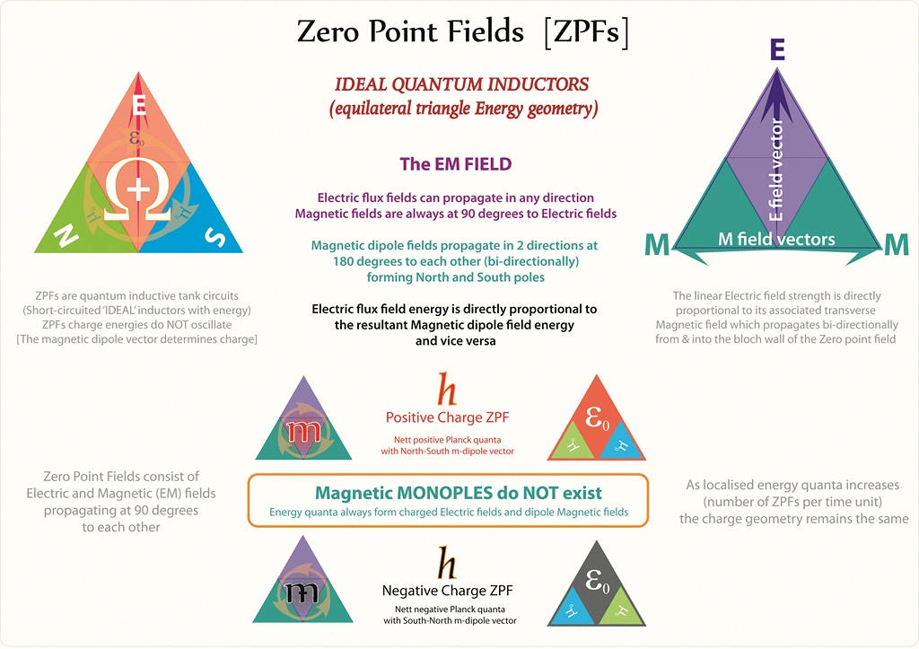
The application of a simple proposition (that Energy has an equilateral geometry) opens the door on a greater understanding of the mechanics of the quantum world, a realm that will be forever beyond the reach of our physical eyes.

The myriad of perplexing properties of quantum properties (such as Charge, mass & Matter) and the astonishing outcomes of quantum experiments (Interference and Wave-Particle duality) can now all be readily modelled and explained rationally on a solid geometric footing.
- Quantized Angular Momenta

Building on the priori that the [squared] numbers of physics are in fact mathematical reflections of an geometric [equilateral] energy quantization, it can be quickly demonstrated that any measurement of scalar energies over Time results in a geometric unit of measurement that has historically be taken to represent rotational motion.
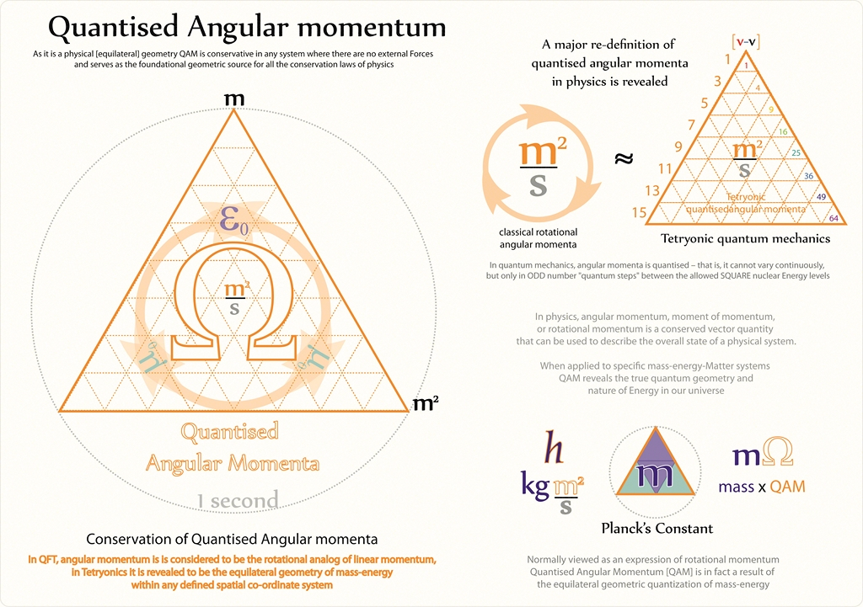
This unit of motion is found throughout Quantum Mechanics and is directly related to the squared energy levels of quantum processes and physics in general.

EM fields of energy momenta are constrained within this equilateral geometry and this geometry lies at the heart of understanding the quantum world in all its beauty.

It determines properties such as Electric permittivity and Magnetic permeability, the vector direction of linear momentum and relates the scalar property of electromagnetic mass directly to velocity.
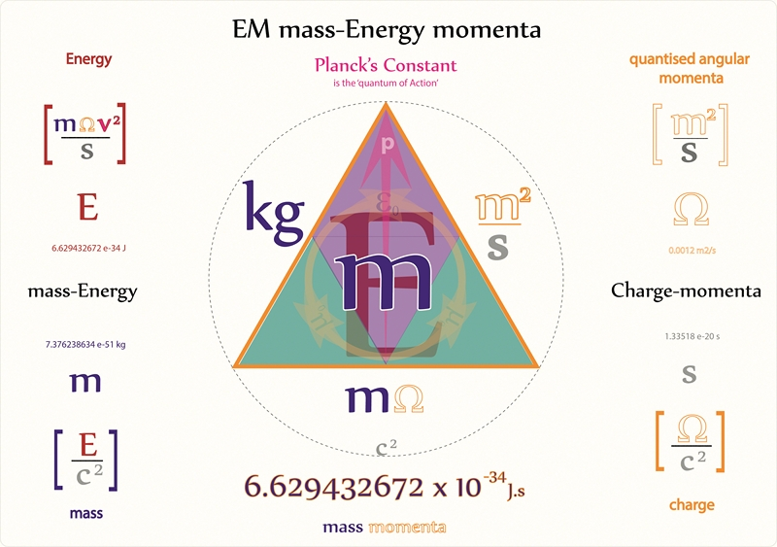
The most recent attempt to explain these properties was Special Relativity theory which in turn led to our current models of the source and physics of charge as being due, in part, to the Lorentz contractions of charged particles in motion.
- Quantum Charges

A fundamental property of all mass-ENERGY-Matter that gives rise to the Forces of electrical Interaction has eluded physical explanation by Physicists since its discovery and led to many ‘band aid’ additions to the Standard model in attempts to explain its observed properties.

SR explains charge as an invariant property of electrostatic bodies and that the motion of charges creates an additional magnetic moment through the relativistic distortion of spherical bodies of Matter.

Equilateral Planck energy momenta geometries and Matter topologies offer a completely different explanation for the source of electrostatic charges and their associated magnetic moments.
Positive and Negative charges are revealed to be opposite side of the same quantum energy ‘qoin’, and can be modelled electrically as ideal quantum inductive loops.

It is equilateral geometry that gives rise to the physical properties of quantized angular momenta, inertial mass, elementary charges
and even the geometric topology of Matter itself.
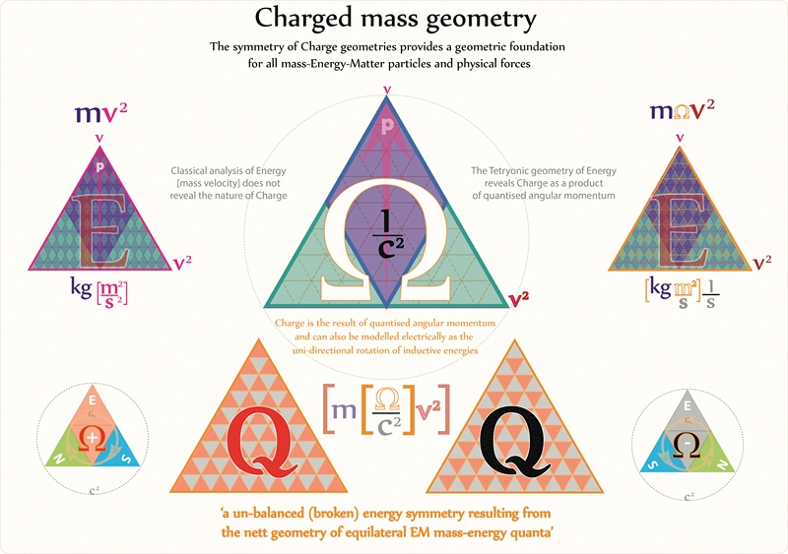
In a planar 2D form they form various EM field geometries but it is when they form the topology of 3D Matter they are expressed as either Positive or Negative electric charge fascia.

ODD number energy quanta [W Bosons] combine via their inductive magnetic dipole fields in fixed quantum steps to create the ‘squared’ nuclear energy levels so familiar to quantum mechanics and form the basis for ElectroMagnetic Induction.

And the tessellation and interaction of countless equilateral geometries provides for an intrinsic connection between EM mass-energy geometries, charge and Matter topologies.

Their rigid equilateral geometries provides the source for relativistic charge invariance and the quantum mechanisms of photo-electron transitions in atoms while the net energy momenta quanta in charged geometries creates the electromotive force known as Voltage in electrical theories.

- ELECTROMAGNETIC MASS-ENERGY-MATTER
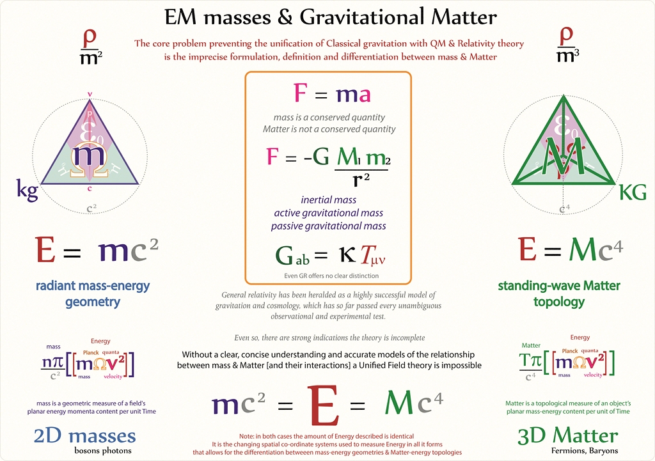

All Energy has an EM mass equivalence and equally any material object with EM mass has an energy equivalence

But there has never been a formal scientific definition and differentiation between 2d mass and 3D Matter along with an associated equation to distinguish these physical properties of EM fields and particles as they exist in physics.

Using Tetryonic geometry it can be clearly demonstrated that ElectroMagnetic mass is NOT Matter – mass is the planar energy content of a system per unit of time [E/c2] in total agreement with Einstein (and all before him) however, lacking a formal definition of either mass and Matter have become so mired with each other so much that they are often freely exchanged for each other inappropriately even in scientific peer-reviewed literature.
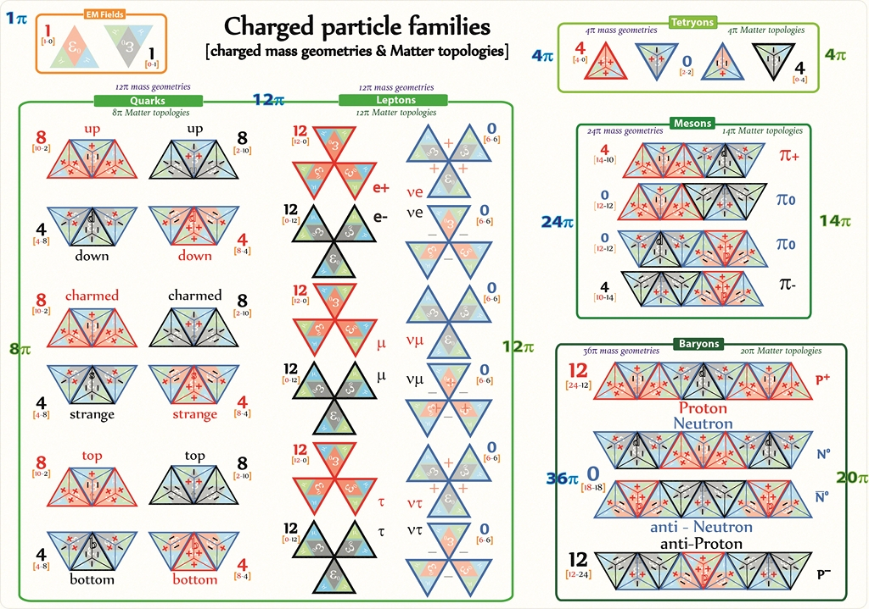

2d mass-energy can be viewed as the canvas from which
3D Matter is created when it is folded into the tetrahedral standing-wave topologies of mass-energy-Matter

ElectroMagnetic mass is the two dimensional (planar) measurement of Energy per second whereas Matter is a measure of the tetrahedral energy topologies found in a spherical spatial volume.

3D Matter topologies can now formally defined geometrically as 4nπ tetrahedral standing waves of EM energy, and it can be asserted that it is the tetrahedral topology of Tetryons that forms the foundation for all large scale Matter in the Universe (not spherical point particles).

It is geometric quantum EM charge interactions that allows equilateral 2D mass-energies to form a Tetryonic topology giving volume to 3D Matter and its electromagnetic energy momenta provides the interactive forces between particles that imbues motion into our Universe.
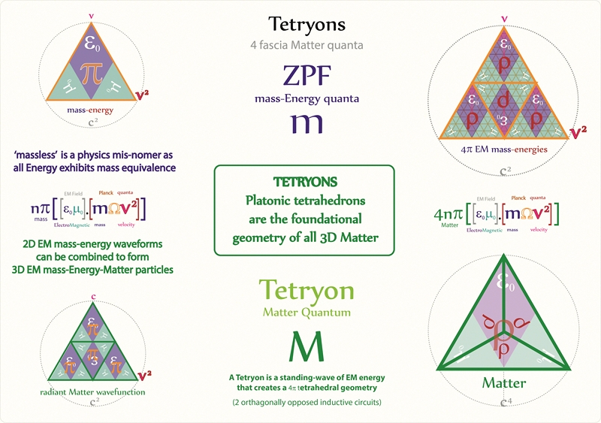
2D mass-energy geometries 3D mass-Matter topologies

Matter at rest is comprised of EM mass-energies that are always in motion and propagating in a tetrahedral EM standing wave.

‘Massless particles’ – so often used as a term in physics to denote ‘matter-less geometries’ is now shown in Tetryonic theory to be a physical misnomer that should be removed from the scientific vocabulary except where it specifically refers to empty space (devoid of any energies).

‘Tetryonics – The charged geometry of EM mass-ENERGY-Matter’ whose founding principle is that EQUILATERAL Planck energies are the foundation geometry for all quantum mechanical processes is presented here as just such a solution to many of the current quandaries of Quantum Theory.

- Sub-Atomic Particles

Using equilateral energy momenta all the 2d mass-energy geometries & 3D Matter topologies of EM fields and particles can be physically modelled revealing the known Standard Model particles and a hitherto unknown particle – the Tetryon.

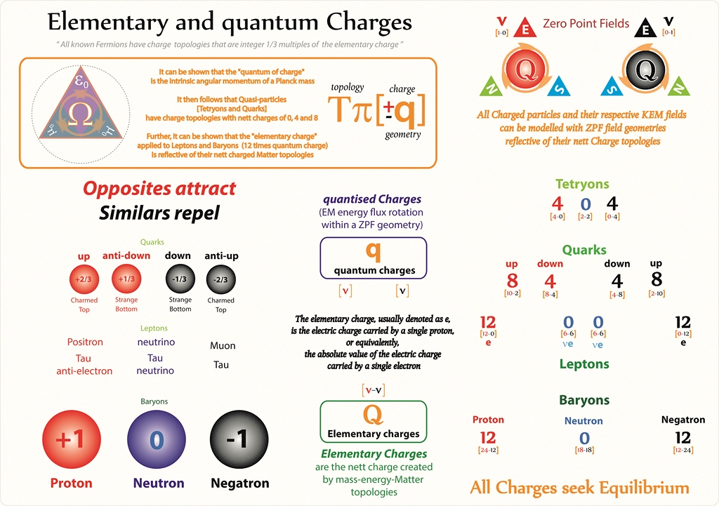
Bosons are shown to be transverse EM fields that facilitate EM induction and Photons are revealed as longitudinal dual-charge pairs possessing a neutral EM charge and inherent magnetic moment.

The net unidirectional momentum of Bosons then distinguishes them from Photons that possess a bi-directional momentum

2D EM masses [bosons-photons] do not have the physical property of 3D topology [Matter] possessed by Fermions and
Fermions can now be defined as the standing wave energy topologies that create all the known sub-atomic particles – the building blocks of large scale Matter and structure in the macro world.

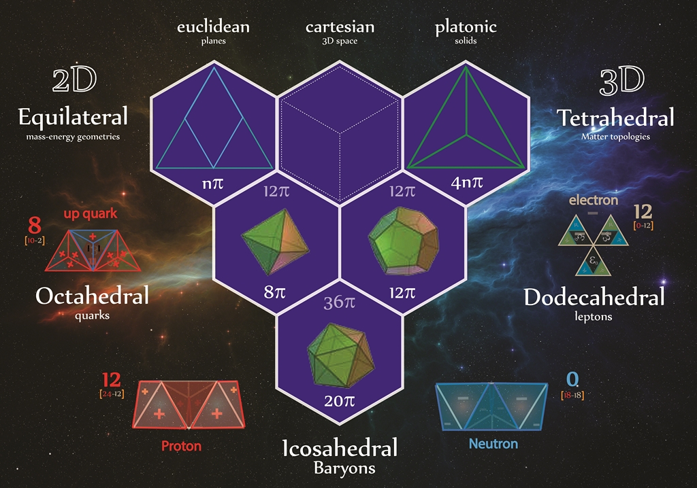Historically these particles have been classified according to their charges and masses, Tetryonic geometry now provides a 3D physical model of all the particles highlighting the physical source of the partial charges of quarks and revealing charge to be the foundational geometric property of all Matter particles.

Tetryons are 4nπ charge topologies that are the foundational quanta of Matter and surprisingly have a mass-charge ratio identical to that of leptons explaining how these particles have remained hidden within existing accelerator experiment results.

Quarks and leptons are 12π charge mass-energy geometries where the attractive strong force interactions between their charged fascia creates 8π particle topologies [quarks] with entirely different physical properties to that of Leptons [12π charge topologies] whose repulsive fascia arrangements result in them forming the quantum equivalent of a 6 loop electrical rotor

Baryons [Protons and Neutrons] are 36π charge mass-energy geometries that result in 20π Baryon topologies with identical mass-Matter topologies but differing elementary charges

- The sub-atomic Particle Zoo

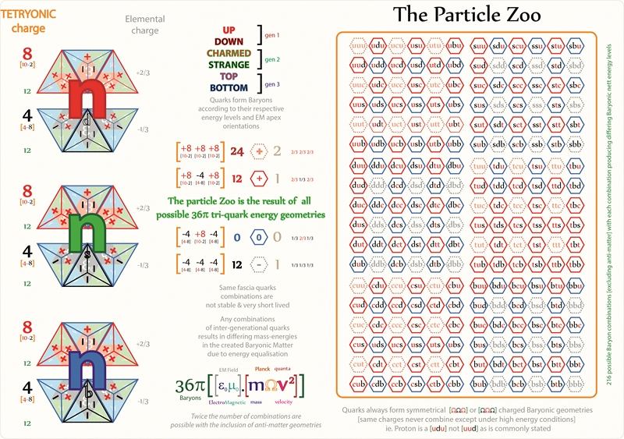
Baryons – the building blocks of atomic nuclei can be formed from many tri-quark combinations of differing quantum energy levels and this is of particular note when modern accelerators are used to probe atomic structures.

The higher energies they employ when colliding particles together results in higher 2D kinetic energies (and increased energy quanta) which recombine after collisions into a plethora of similar particles called the Particle Zoo.

A sound understanding of EM mass-energy geometries & the charged topologies of all sub-atomic Matter particles reveals the true genesis of all of the Baryons to be found in the particle zoo.
Tetryonic geometries facilitate the precise 3D modelling of all the periodic elements, allotropes and compounds enabling the development of new classes of materials and medicines providing us with many new insights into Quantum Chemistry and large scale Matter in general.

- Quantum Electro-Dynamics [QED]

Adding to the mysteries of quantum mechanics is a number of well-known QED effects that have also eluded physical explanation – to date
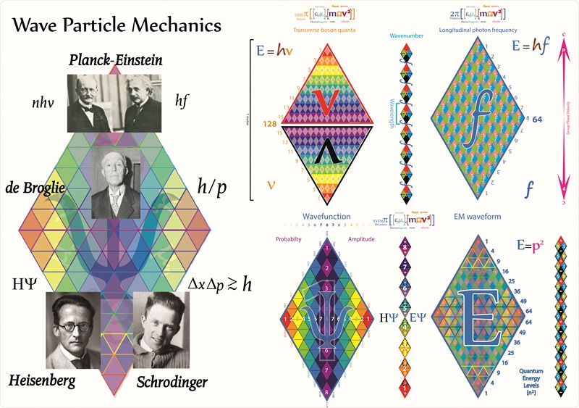
In 1865, James Maxwell Clerk unified the then disparate theories of Electric and Magnetic fields into a theory of Electromagnetism and related then to the velocity of light.

The exact quantum geometry for EM wave geometries (and the photons comprising them) that explains their Wave-functions and observed inference patterns represents one of the greatest challenges to developing a concise fully realized quantum theory of EM radiation.

Wave-Particle duality dating back to the 17th century is perhaps the best known example of quantum behavior that has defied precise modelling despite intense effort by scientists around the World for over two centuries

The application of equilateral Planck mass-energy momenta to the charged geometries of Photons and EM waves not only explains these long standing mysteries but also removes the quantum fuzziness introduced by Heisenberg’s Uncertainty principle, in turn clearing the way for Science to develop an advanced understanding of Electricity, its role in Quantum Electrodynamics and provide new clean forms of energy from quantum processes.

- Photo-electrons and spectral lines

The physical relationship between Spectral lines, Rydberg’s Constant and the Kinetic energies of Photo-electrons as they interact with photons and atomic nuclei is quickly revealed when equilateral energy geometries are employed

It is the rigid geometry of equilateral Planck energy momenta that gives rise to the invisible forces of Faraday’s Electric and Gauss’ Magnetic fields as well as Newton’s Action-at-a-Distance.

Quantized Angular Momentum, a direct measure of the long hidden equilateral geometry of Energy, is revealed as the quantum source of Charge, the physical constants and even the geometry of EM mass-energy & Matter itself.

Square root linear Forces and geometric constants of
Interaction resulting from equilateral EM energy geometries have been mistakenly developed into three disparate nuclear forces:

- The EM Force is the result of 2n charge geometries acting along transverse or longitudinal directions (or in superposition) in the forms of Bosons and Photons
- The Weak Force is the inductive coupling of the magnetic permeability of adjacent energy geometries
- The Strong Force is the attractive force between opposite charged fascia of Tetryonic Matter. It can also form a repulsive force between similar charged fasciae resulting in charged Leptons [electrons].
- Gravitation (mathematically identical to Coulomb’s Force save for strength and source) can also be modelled as the geometric mean of super-positioned EM waves of differing energy density and vector direction.

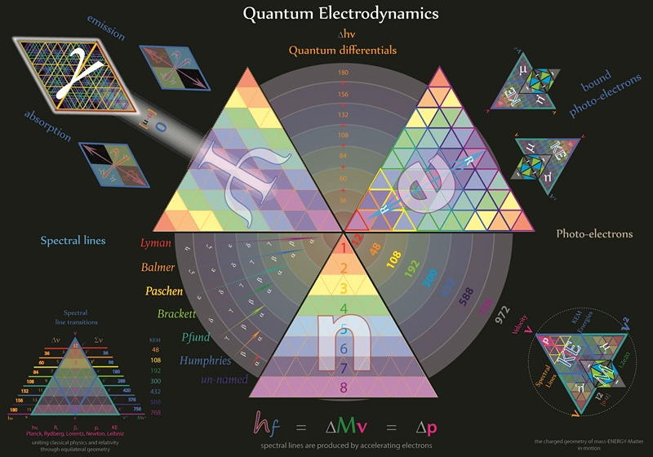

Fermat’s difference of two squares at work in QED

Additionally, the distribution of equilateral Planck energy momenta in the secondary KEM fields of material particles in motion readily explains a number of diverse QED phenomena such as:
- Spectral Series emissions,
- Quantum transitions between ‘squared’ energy levels for electrons bound to atomic nuclei
- The statistical distribution of energy momenta in quantum systems
- Wave~Particle duality and
- Quantum Interference patterns
- 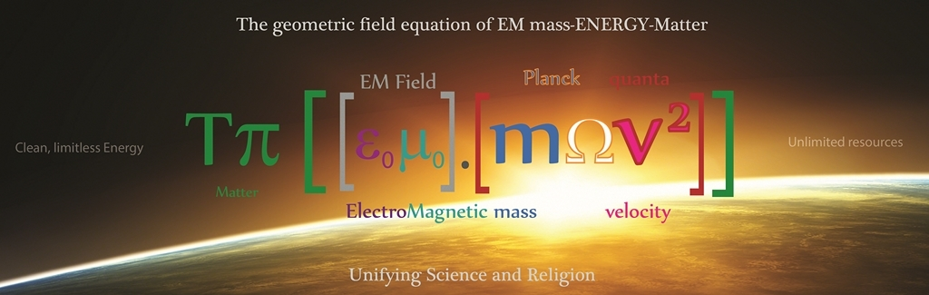Quantum Chemistry

Geometrically extending the Aufbau principle using charged Planck geometries also leads to many refinements in chemical engineering and has facilitated the building of accurate 3D CAD models of all elements, isotopes and molecular compounds

Every element can now be analyzed from the quantum level up revealing its exact 3D topology, quark configuration, rest mass-Matter-energies and chemical properties. And number of chemical theory misconceptions can be quickly clarified and corrected in turn advancing our understanding to the physical mechanics underlying chemical processes like atomic and ionic bonding, element family properties and the 3D structures of complex chemical compounds and molecules.
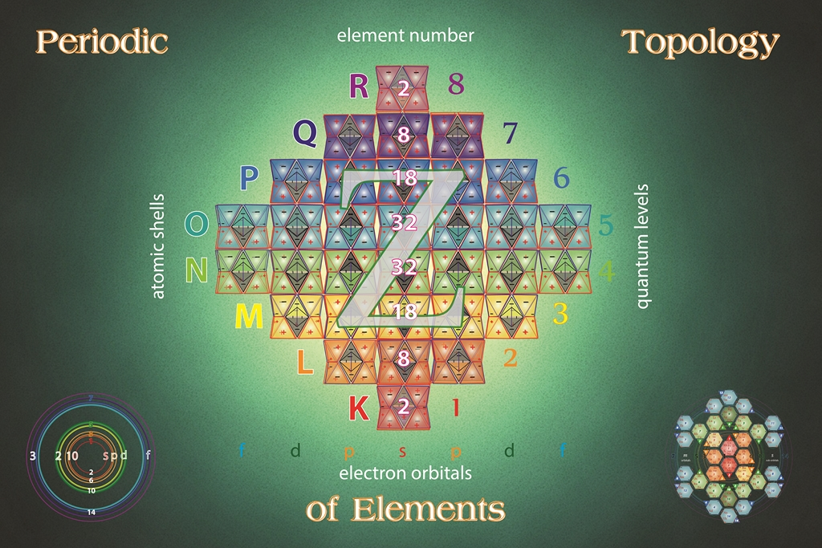
Applying these same equilateral Planck mass-energy geometries and tetrahedral Matter topologies to quantum chemistry leads to a number of significant advances in the understanding of chemical processes most notably:

- Accurate models for all periodic elements and their associated allotropes
- Advanced molecular orbitals plots
- Exact rest masses for all elements and
- A new Periodic table based on the charged topologies of Matter

In addition to the 120 periodic elements, Hydrocarbons and Carbohydrates have also been modelled using equilateral charge topologies with the results matching the established chemical quantum models of Bohr and Schrodinger.

Highly detailed, interactive quantum models of all chemical elements and compounds will allow us to model chemical and biological structures in hitherto unimagined detail and facilitate the modelling of increasingly complex biological processes.

Even DNA can be modelled in 3 dimensions leading to a greater understanding of the role of quantum mechanics in biological processes along with the interaction and effect of EM radiation on organic compounds.

A unified geometric field equation

In physics a Unified Field Theory is a type of theory that allows all that is usually thought of as a fundamental force or elementary particle to be formulated in terms of a single equation that explains all their disparate properties.

It is considered the holy grail of Science, offering the promise of advances in Technology, Energy and Medicine unparalleled in Human history.

Equilateral energy provides the foundation for the creation of a single equation that expresses EM mass-ENERGY and Matter as the result of geometric & topological charge interactions.

Applying equilateral geometry to Planck energy momenta quanta has been shown to firmly resolve many of the current mysteries plaguing the Standard model and provides a firm foundation for the development of a single unified quantum theory uniting all quantum and macroscopic forces.

It effortlessly merges all the tested features of Classical mechanics with the statistical probabilities of quantum mechanics and scales up to the cosmological scale of General Relativity.

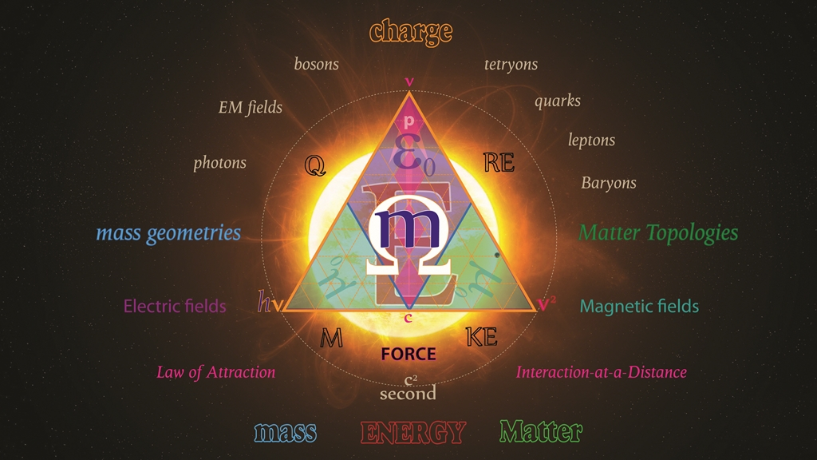Equilateral charged energy momenta geometries provide a rigorous framework for quantifiable foundational advances in:

- Quantum Mechanics
- Quantum Electrodynamics
- Quantum Chemistry
- Quantum Cosmology
- Quantum Biology
- The Mathematics of Physics and
- Energy and Communications

Mathematical principles such as re-normalization, statistical probabilities and square roots of negative numbers can all be geometrically rationalized and modelled through Tetryonics leading to further advances in mathematical fields such as:
Cryptography, quantum computing and telecommunications
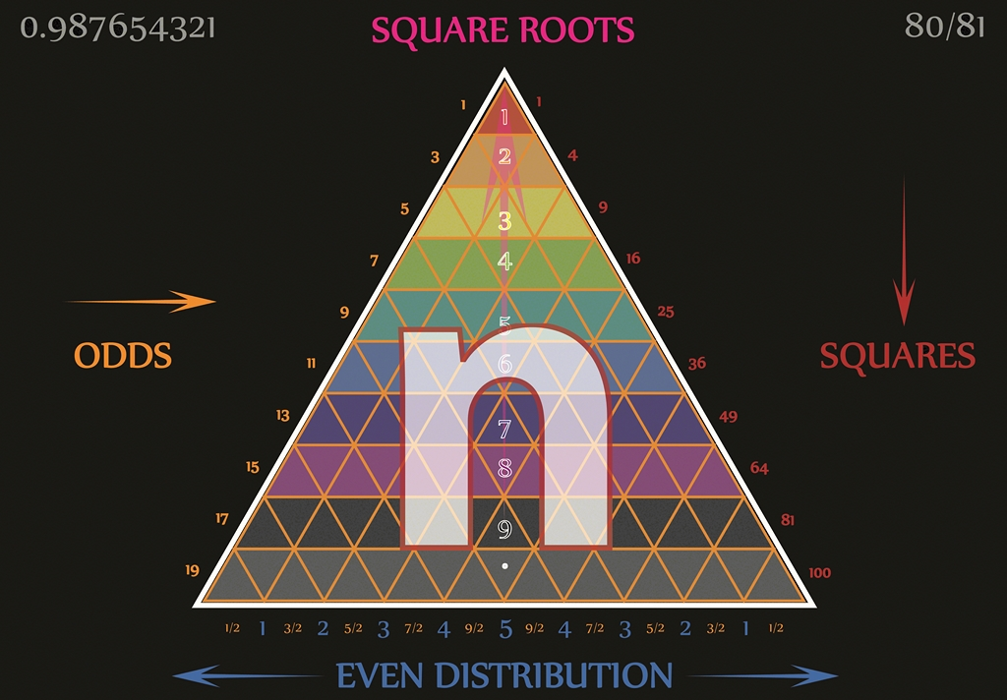
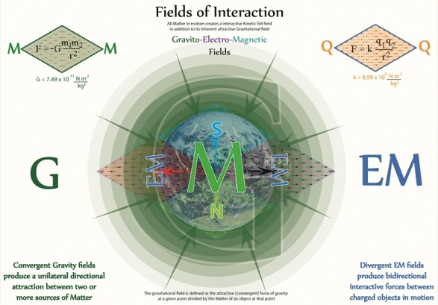The charged equilateral geometry of Tetryonics corrects many of the erroneous postulates and theories that have been developed during the last 100 years providing a solid foundation for further major advances in science and mathematics.

- Universal Quantum Gravitation

The force of Gravity has been long-held to be the mysterious force that holds our Universe together, shaping the Stars and holding us to the Earth as we orbit our own SUN.

Tetryonic geometry reveals its quantum mechanics to be the result of electromagnetic fields and the force produced by the positive topological displacement of vacuum energies by Matter in these spatially defined fields of observation.

What Newton saw as a force that acts instantaneously between separated bodies of Matter, Einstein modelled as a motion that is the result of the ‘curvature of Spacetime’.
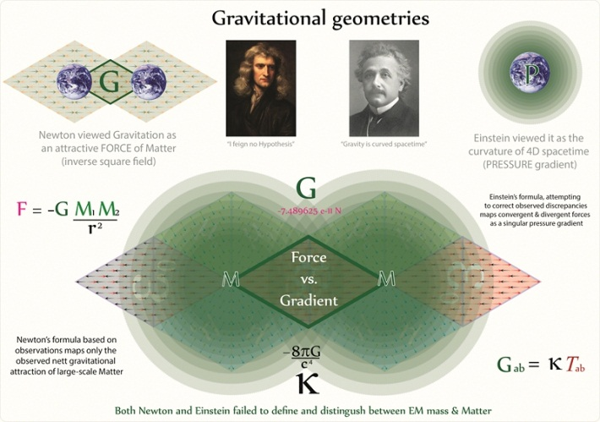
In fact the Gravitational field is comprised of 3 separate vector force components at the quantum level, each of which produces differing forces of interaction, but all combine to produce the nett Gravitational field that we observe and describe as the attractive force of Gravity.

These three quantum forces [G+E+M] produce a nett vector field of convergent gravitational acceleration that was initially so eloquently modelled by Newton back in the 16th century through his inverse square law.

Electric fields of force and energy momenta diverge radially from all Matter as it is heated, or placed in motion by other forces creating an interactive field with both divergent and convergent equatorial regions of acceleration with their dipole Magnetic fields (located around the Polar Regions of Matter) also create a perturbative force on bodies close to them

Although Newton’s and Einstein’s theories were both correct in their respective analysis of the forces at work, they both failed to define and distinguish between EM masses and Matter leading to the continued debate over the true nature and physical understanding of the actual mechanics of quantum gravitation.

Gravitational fields are created by the topology of Matter itself as it displaces vacuum energies surrounding it and their radiant EM energies accelerate particles within their interactive EM fields.

GEM fields and their associated field singularities also combine to produce the stellar mechanics that power the Stars –

A Gravitic-Electro-Magnetic pinch.

While the nett convergent force of Gravity, created by the positive displacement topology of 3D Matter accelerates material objects toward the core of Stars, the GEM pinch field singularity at the core of the Star collapses physical 3D Matter topologies, releasing their stored 2D ElectroMagnetic mass-energy momenta as radiant light and heat into the surrounding space.

Stars do not fuse elements to release energy – they pinch Matter topologies to release radiant mass-energy geometries
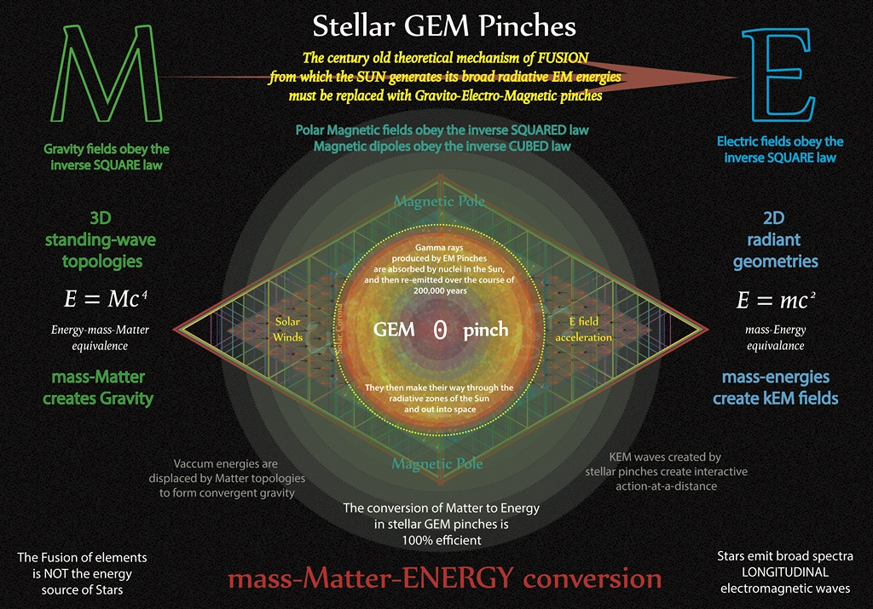
- Energy from the Stars

The 3D standing-wave topologies of all Matter provide a rigid structure that displaces the surrounding Vacuum energies and creates a pressure gradient which we call attractive Gravity.

And the destruction of these Matter topologies in turn creates radiant energies that propagate out into the surrounding space eventually weakening to form vacuum energies that permeate all of Space.

This eternal cycle of Matter creation and destruction within Stars and Galaxies is what drives the Universe we see today causing it to contract as it forms gravitational Matter and to expand as it restructures the standing-wave Matter into radiant forms of Energy (Light and heat).

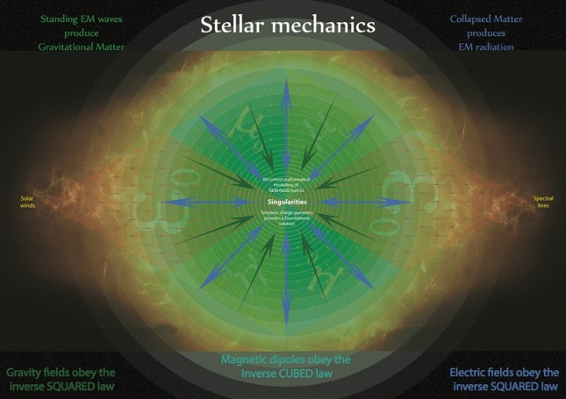The same process offers us a source of clean, limitless energy for all our needs as well as unlimited resources by restructuring 3D Matter into radiant mass-energies with 100% efficiency.

Our toxic stockpiles of radioactive wastes can be completely eliminated from the environment and electrical power can be safely stored as non-radioactive masses within macro-scale models of the deuterium nuclei and distributed worldwide to any location without the need for transmission lines.

Clean, limitless energies can now be created by correcting our current model and understanding of stellar ‘fusion’ through the application of equilateral Planck energies and the Tetryonic unified field equation of mass-ENERGY-Matter to our needs.

For the first time in Humanity’s history, we find we have the chance to advance our civilization to new pinnacles of technology and understanding in turn leaving our World a better place than we found it to be.

Age old dilemmas of technological and scientific advancement at the cost of environmental pollution and climate change is at an end

Older nuclear and hydro-electric storage schemes can be eliminated and replaced, returning water courses and environments to their original natural states in turn reducing tensions and conflicts stemming from the availability of energy resources worldwide.

Tetryonic theory offers a new geometric perspective that builds on the foundations of Classical, Quantum and Relativistic theories, unites all these disparate scientific disciplines through equilateral Planck quanta of mass-energy momenta and paves the way forward for new discoveries and a greater understanding of the mechanics of mass-ENERGY-Matter and fields of Force on all scales of physics in our Universe

ACKNOWLEDGMENTS
- Ranjith Reddy, Engineering Student, Hyderabad, A.P,India.
- Rene Cormier, 3D CAD modelling, Calgary, Canada
- Richard Blankenship, Web Design, Oklahoma, America
- Otto van Nieuwenhuijze, Audio lectures, Netherlands

REFERENCES
1. www.tetryonics.com
2. www.tetryonics101.com
3. http://tetryonics.scienceoflife.nl/html/interviews.html

Author - KELVIN ABRAHAM
Correspondence Author – Kelvin C. ABARHAM,
kelvin@abraham.net.au, answers@tetryonics.com
+61403410306

